

1000+ Industry Relevant Courses || 500+ Industry Veteran Trainers

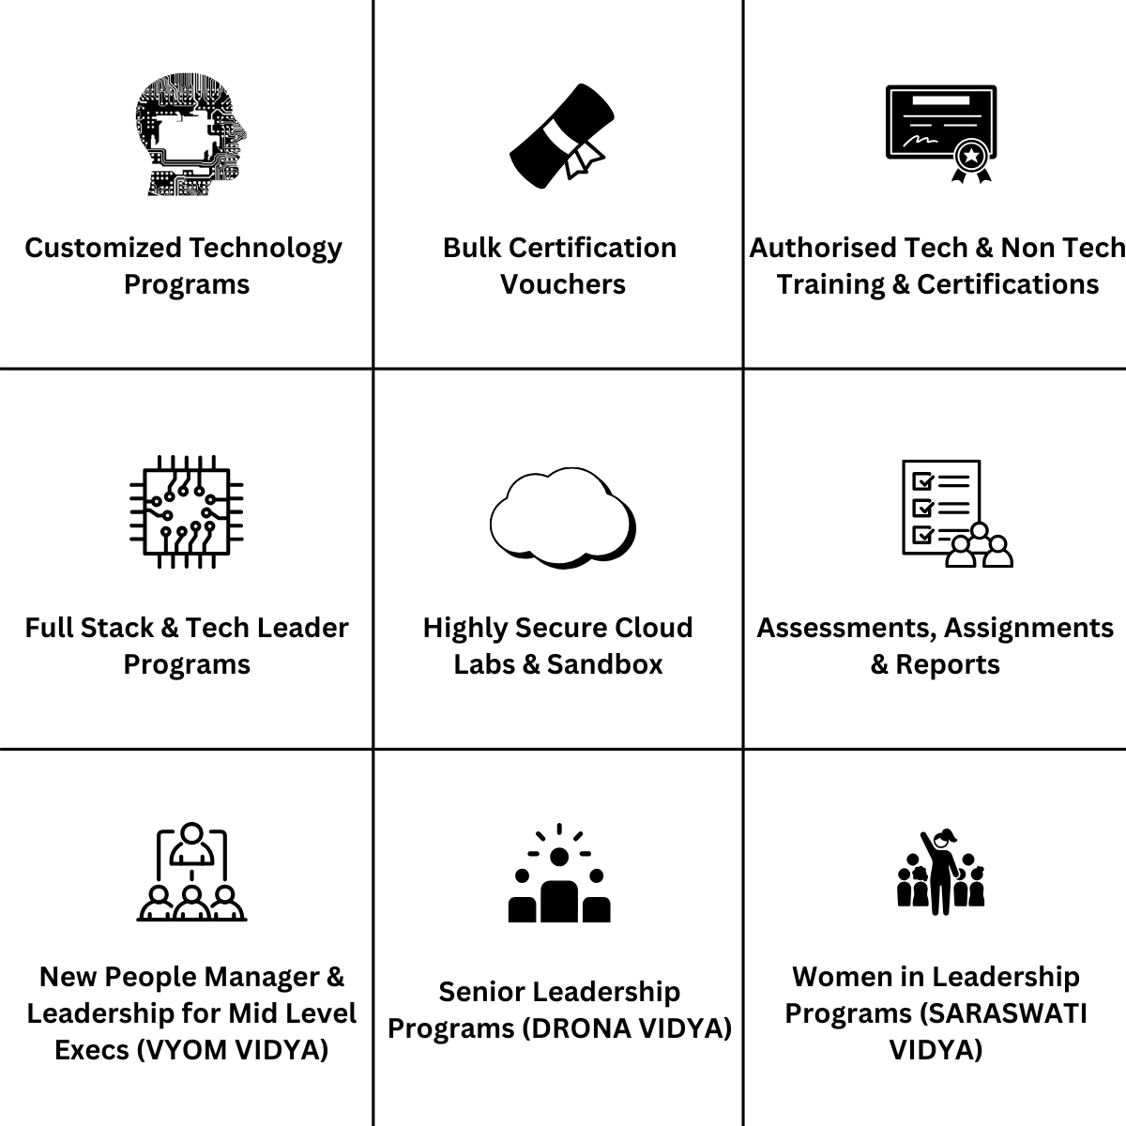

ML, AI & Gen AI || Cloud (AWS, Azure, Google Cloud) || Cyber Security || Data Engineering || DevOps || Programming Languages || Java/J2EE || Microsoft Technologies || Mobile & Web Technologies || Agile || Project Management || Business Analysis

Course Name

Agentic AI for Developers

Overview

Taking hands-on developers already exposed to GenAI to the next level. Not just developing with agentic AI solutions, but actually developing, designing, architecting, deploying & monitoring Agentic AI solutions. Bringing in a mindset shift from traditional development flows to exploiting the latest in generative and agentic AI and discovering its potential and scale.

Prerequisite

- Comfort with development tools (VSCode, CLI, etc)
- Basic comfort with GenAI concepts and using Agentic AI solutions

Duration

2 Days

Course Contents

Day 1
AI developing exercise [1 hr]
Goals: Start with a bang, establish baseline for class’s readiness
- Hands-on
  - Take a loose specification to working code
  - Get working test-cases
- Debrief & discussion
  - Discuss prompting strategies used
  - Draw a word cloud of known AI terms, concepts
  - Set the agenda for the training

The Generative AI Landscape [1 hrs]
Goals: Bringing a mixed background audience to the same page on AI
- Evolution from ML to LLMs and foundation models
- Key GenAI model types (text, vision, multi-modal)
- API based services: OpenAI, Anthropic
- HuggingFace Hub and transformers framework
- Agentic AI: LlamaIndex, langchain, langgraph, langsmith
- Hands-on: Exploring APIs (OpenAI, Hugging Face) and model playgrounds

Anatomy of Large Language Models [1 hrs]
Goals: Conceptual understanding of the internals of the AI domain, strengths and limitations
- Architecture of transformers
- Embedding models vs seq2seq models
- How LLMs learn patterns, context, and semantics
- Fine-tuning vs. prompt-tuning vs. adapters
- Instruction Tuning
- Context Window: Why models hallucinate

Multimodal LLMs & Context Engineering [1.5 hrs]
Goals: Appreciating variety of LLM use-cases, extract maximum benefit using prompt/context engineering
- What multimodal LLMs are (text, image, audio, video)
- Use cases where multimodal matters
- Context engineering
  - System prompts
  - Few-shot examples
  - Structured outputs
- Idiomatic prompts for JS/TS (Node/Express) and Python (FastAPI/Django-style)
- Prompt design anti-patterns: vague asks, under-specified context, mixing concerns
- Guardrails and constraints
Hands-on (mini-exercises in repo):
- Turn natural-language requirements into structured prompts that generate:
  - An Express route + middleware.
  - A Python data processing function + docstring.

GitHub Copilot Core + Chat for Everyday Coding [1.5 hrs]
Goals: Make sure everyone uses Copilot beyond “autocomplete,” with good habits.
- Copilot in VS Code: inline completions, ghost text, multi-line suggestions.
- Copilot Chat: using /explain, /fix, /tests on selected code.
- Providing context: file selection, workspace context, past errors.
- Using Copilot for:
  - Boilerplate (routes, controllers, DTOs, models).
  - Test skeletons (Jest for Node, pytest for Python).
  - Documentation and basic diagrams (textual).
Hands-on:
- Starting with a partially implemented Node API, use Copilot to:
  - Complete controller logic.
  - Generate unit tests.
  - Ask Chat to explain and then refactor a messy function.
Copilot for Debugging and Incremental Refactoring [1.5 hrs]
Goals: Normalize using Copilot as a debugging and refactoring assistant, not just a generator.
- Using Copilot Chat on error stacks, failing tests, suspicious code paths.
- Patterns for rubber-duck debugging via Chat: “Here’s the error, here’s what I tried…”
- Using /fix-style interactions (or equivalent) to propose patches, then reviewing them.
- Refactoring patterns:
  - Extract function, split modules, clarify types in TypeScript.
  - From callback hell to async/await, from nested “if” trees to guard clauses.
Hands-on:
- Given a Node + Python repo with seeded bugs and code smells:
  - Use Copilot Chat to locate root causes and propose fixes.
  - Use Copilot to refactor for readability and better separation of concerns.

RAG Fundamentals & Document Intelligence [2 hrs]
Goals: Participants can build a working RAG system and understand its tradeoffs
- Why RAG exists (limitations of pure prompting)
- RAG architecture overview
- Real-world examples (enterprise search, support bots)
- RAG data pipeline:
  - Ingestion
  - Chunking strategies (fixed, semantic, hierarchical)
  - Embeddings
  - Vector databases
- Similarity search:
  - Cosine similarity
  - Hybrid search (BM25 + vector)
- Metadata filtering
Hands-on
- Code walkthrough: Basic RAG application
- Query → retrieval → answer traceability

Day 2

Tools and Ecosystems for LLM Agents [1 hrs]
Goals: Overview and demo to set context of Agentic AI
- Langchain
- HuggingFace
- Vector Stores (ChromaDB, FAISS, pinecone)
- Tool Calling interface
- Orchestration

Demo + Hands-on: Hugging face hub and CLI

Agentic AI Fundamentals & Design Patterns [2 hrs]
Goals: Participants understand how agents think, act, and fail
- What is an AI Agent vs LLM app
- Role of LLMs vs SLMs in agents
- Core agent control loop:
  - Observe → Think → Act
  - State management
  - Autonomy boundaries & guardrails
- Design patterns:
  - Tool / function calling
  - Planning &amp; decomposition
  - Reflection &amp; self-critique
  - ReAct pattern
- Single-agent vs multi-agent systems
- Designing an agent from scratch:
  - Goal
  - Tools
  - Memory
  - Constraints

Agentic AI with langchain [1 hrs]
Goals: Understanding in-depth capabilities of langchain+langgraph frameworks
- LangChain agents
- Custom tools
- Conversation with a ReAct agent
- Chatbots with LangGraph
- Adding nodes and Edges
- Graph memory for conversations
- Mutli-agent systems with langgraph

Deploying Agentic Applications [1.5 hrs]
Goals: Appreciating quick as well as formal model serving use-cases; getting MVP’s as well as production-grade systems ready
- Streamlit and Gradio
- Creating a first interactive app
- Adding widgets elements
- Displaying Outputs
- Dashboards
- Feedback Capture and logging mechanism
- Local vs Cloud hosting
- Azure API
- AWS API
- Cost & usage analysis
- Security concerns and mitigations
Spec-Driven Development (SDD) [1 hrs]
Goals: Use Copilot Spec-kit to build and wire an end-to-end feature across Node backend and simple frontend.
- Github Copilot Spec Kit
- Designing a feature spec (e.g., “Task management with filters and activity log”).
- Using Copilot to:
  - Scaffold Node/Express endpoints and Mongo models.
  - Generate a minimal React/Angular component that consumes the API.
  - Add basic validation and error handling.
Hands-on (guided build):
- From empty or thin skeleton repo, implement one vertical slice:
  - API endpoints (create/read/update entity).
  - Simple frontend (form + list page) calling the API.
- Use Copilot for 70–80% of boilerplate; participants focus on reviewing and adjusting.
Wind-down, Q&A, Way forward [1 hrs]
- Ethical issues : privacy, IP rights, legal liability
- Security and Guardrails
- Deployments and drift
- Immediate productivity-gain use-cases

Post-Training
Mini Capstone: Copilot-Accelerated Application Enhancement [1.5 hrs]
Goals: Let mixed-experience devs work at their own level on a realistic small project, using Copilot as a multiplier.
Structure:
- Teams pick one enhancement path on a provided repo (Node backend + light frontend):
  - Add a non-trivial feature (e.g., role-based access control, audit logging).
  - Do a structured refactor (modularization, type-safety, test coverage).
  - Improve observability (logging, error handling, monitoring hooks).
- Process (agentic style):
  - Use Copilot CLI to understand current structure and propose a plan.
  - Use Copilot Chat to iterate on implementation, tests, and documentation.
  - Keep humans in control: review diffs carefully, adjust prompts, enforce standards.

Stretch Goals

Performance, Testing, and Refactoring with Copilot [1.5 hrs]
Goals: Show how Copilot can support profiling, optimization, and test coverage improvements.
- Identifying hotspots: inefficient queries, N+1 issues, heavy loops.
- Asking Copilot to:
  - Propose more efficient DB queries or caching layers.
  - Suggest micro-benchmarks or load-test scaffolds.
  - Generate missing tests focused on edge cases and boundaries.
- Refactoring patterns with Copilot:
  - Split monolithic services, introduce service layers.
  - Introduce TypeScript types and interfaces into JS-heavy codebases.
Hands-on:
- Given a “working but slow” Node/Python service:
  - Use Copilot to identify suspected performance issues.
  - Apply Copilot-guided refactors (e.g., indexing, batching, caching).
  - Generate/expand tests to guard behavior during refactor.

Deliverables by end of session:
- Working code for the chosen enhancement.
- A short “diff review” where each team explains:
  - How Copilot was used.
  - What they accepted, edited, or rejected.
  - Any productivity or quality insights.

